A brief overview of the LabProxy Package

Paolo Buschiazzo and Michael Niederstaetter

Package content:
- Lab Proxy
- Library (in ASP.NET and PHP)
- Demo lab (in ASP.NET and PHP)

LabProxy:
The idea of the LabProxy is to extend a conventional Lab Server (for instance Time of Day Example). Starting from the Process Agent base class a new web service method “getReservationInfo()” was added which provides an interface between the ISA and any kind of laboratory server.
When connecting a laboratory to the ISA one has to setup first of all the iLab services and the LabProxy. (more detailed documentation in the installation package)
The overall idea is that the LabProxy redirects a valid request from the Service Broker to the proper online laboratory server. Therefore the service broker URL (to create a link back) and an ID (to identify the current reservation) are posted to the online laboratory server. The task of the online laboratory server is then to call the “getReservationInfo()” web service on the LabProxy to retrieve the information about the current reservation. This can be done by call the web service method manually or even easier by using the provided libraries (ASP&PHP).

Since the current implementation does not need to store any information about the experiment within ISA on the laboratory system the web service call is only used for the authentication and to retrieve the reservation info. iLab hereby can be considered as a black box (see Figure 1) and has not to be modified further.

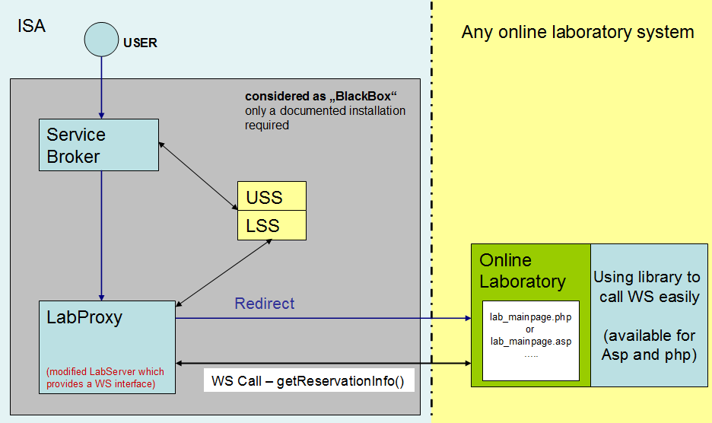
Figure 1: An overview of the provided LabProxy solution

Redirect:
In order to make a redirect to the proper laboratory page the LabProxy must know the URL of the start page. This can be configured in the “Web.comfig” file of the LabProxy. When redirecting to the proper page the passkey and the service broker URL are going to be posted in the following way:

http://test.com/lab/index.php?passkey=“xxx“&sbUrl=“xxx“

Web Method:
In the case one does not want to use the available libraries the following documentation may help to call the web service manually.
Generally two parameters are required to call the web service:
- ID
As ID the passkey is used which is posted from the LabProxy to the online laboratory server when making the redirect
- DATETIME (of the labserver)
Is used to synchronize the reservation time between ISA and the proper lab server. The datetime parameter has to be in the following format:
Y-m-dTH:i:s.uZ --> 2010-07-06T13:41:15.000000Z

The web service method is defined as follows:

SOAP 1.1
The following is a sample SOAP 1.1 request and response. The placeholders shown need to be replaced with actual values.
POST /LPS_MIT/LabProxy.asmx HTTP/1.1
Host: remlab-esng.dibe.unige.it
Content-Type: text/xml; charset=utf-8
Content-Length: length
SOAPAction: "http://ilab.mit.edu/iLabs/Services/GetReservationInfo"

<?xml version="1.0" encoding="utf-8"?>
<soap:Envelope xmlns:xsi="http://www.w3.org/2001/XMLSchema-instance" xmlns:xsd="http://www.w3.org/2001/XMLSchema" xmlns:soap="http://schemas.xmlsoap.org/soap/envelope/">
<soap:Body>
<GetReservationInfo xmlns="http://ilab.mit.edu/iLabs/Services">
<passkey>string</passkey>
<labServerTime>string</labServerTime>
</GetReservationInfo>
</soap:Body>
</soap:Envelope>
HTTP/1.1 200 OK
Content-Type: text/xml; charset=utf-8
Content-Length: length

<?xml version="1.0" encoding="utf-8"?>
<soap:Envelope xmlns:xsi="http://www.w3.org/2001/XMLSchema-instance" xmlns:xsd="http://www.w3.org/2001/XMLSchema" xmlns:soap="http://schemas.xmlsoap.org/soap/envelope/">
<soap:Body>
<GetReservationInfoResponse xmlns="http://ilab.mit.edu/iLabs/Services">
<GetReservationInfoResult>string</GetReservationInfoResult>
</GetReservationInfoResponse>
</soap:Body>
</soap:Envelope>

SOAP 1.2
The following is a sample SOAP 1.2 request and response. The placeholders shown need to be replaced with actual values.
POST /LPS_MIT/LabProxy.asmx HTTP/1.1
Host: remlab-esng.dibe.unige.it
Content-Type: application/soap+xml; charset=utf-8
Content-Length: length

<?xml version="1.0" encoding="utf-8"?>
<soap12:Envelope xmlns:xsi="http://www.w3.org/2001/XMLSchema-instance" xmlns:xsd="http://www.w3.org/2001/XMLSchema" xmlns:soap12="http://www.w3.org/2003/05/soap-envelope">
<soap12:Body>
<GetReservationInfo xmlns="http://ilab.mit.edu/iLabs/Services">
<passkey>string</passkey>
<labServerTime>string</labServerTime>
</GetReservationInfo>
</soap12:Body>
</soap12:Envelope>
HTTP/1.1 200 OK
Content-Type: application/soap+xml; charset=utf-8
Content-Length: length

<?xml version="1.0" encoding="utf-8"?>
<soap12:Envelope xmlns:xsi="http://www.w3.org/2001/XMLSchema-instance" xmlns:xsd="http://www.w3.org/2001/XMLSchema" xmlns:soap12="http://www.w3.org/2003/05/soap-envelope">
<soap12:Body>
<GetReservationInfoResponse xmlns="http://ilab.mit.edu/iLabs/Services">
<GetReservationInfoResult>string</GetReservationInfoResult>
</GetReservationInfoResponse>
</soap12:Body>
</soap12:Envelope>

Hereby the “GetReservationInfoResult” is an XML string according to the following structure:

<Reservation>
<ReservationExpiration>Datetime</ReservationExpiration>
<GroupName>group of the user</GroupName>
<ExperimentID>Experiment execution id</ExperimentID>
</Reservation>

Libraries:

The libraries provided within this package to foster integration of a laboratory provides the following static methods:

Method | Description
RetrieveReservation(string Webservice URL) | Calls a webservice to retrieve reservation information and synchronizes the time of the Labproxy. The URL of the LabProxy web service has to be passed as parameter. (usually it is something like %labproxyroot%/Labproxy.asmx ) The response of the web service will be stored directly within the current session.
isResgistrationValid() | Checks wehther the current registration is still valid by analyzing the current session values.
ReservationExpiration | Gets the ReservationExpiration
ExperimentID | Gets the ExperimentID
GroupName | Gets the GroupName

To use the library one has to include the DLL file in ASP.NET applications.
To include the library in a PHP application one can simply use the “include” functionality to make use of the provided class “labproxy”.
Examples for this use cases are available in the “demo labs” folder.

